Functional & Technical Design Specification of Custom Sap GRC User Access Request Application

Target Audience: ABAP Developers, SAPUI5/Fiori Developers, SAP GRC Consultants, Integration Engineers
Executive Summary & Scope
This specification defines the functional, business, and technical requirements to build a custom Single-Page User Access Request Front-End Application deployed within SAP GRC Access Control (AC).
The application acts as a simplified, user-friendly wrapper over SAP GRC Business Role Management (BRM) and MSMP Workflows. It automates user profile hydration via Active Directory (AD), reads position-based role rules from a custom SAP table (ZGRC_POS_ROLE_MAP), retrieves existing entitlements via standard GRC Web Services, and submits formatted access requests into SAP GRC.

Contents

SECTION 1: FUNCTIONAL SPECIFICATION (FS) 3
1.1 Page Architecture & Layout Principle 3
1.2 Form Wireframe & Section Layout 3
1.3 Detailed Section Specifications & Business Rules 3
1.4 Form Visibility & Data Rule Summary Matrix 6
SECTION 2: TECHNICAL SPECIFICATION (TS) 7
2.1 End-to-End System Integration Flow 7
2.2 Custom Database Table Schema (ZGRC_POS_ROLE_MAP) 8
2.3 Interface & API Specifications 8
SECTION 3: GRC CONFIGURATION & PREREQUISITES 13
3.1 Web Service Activation (SICF Transaction) 13
3.2 MSMP Workflow Binding (SPRO) 13

SECTION 1: FUNCTIONAL SPECIFICATION (FS)

1.1 Page Architecture & Layout Principle
- Layout Pattern: Single-Page Canvas / SAP Fiori Object Page Layout (no wizard steps or multi-page transitions).
- Grid Layout: Form fields are grouped inside responsive, structured card containers.
- Header Bar: Displays application title and authenticated user profile details.
- Footer Toolbar: Fixed at the bottom containing global form actions: Clear Form and Submit Request.

1.2 Form Wireframe & Section Layout
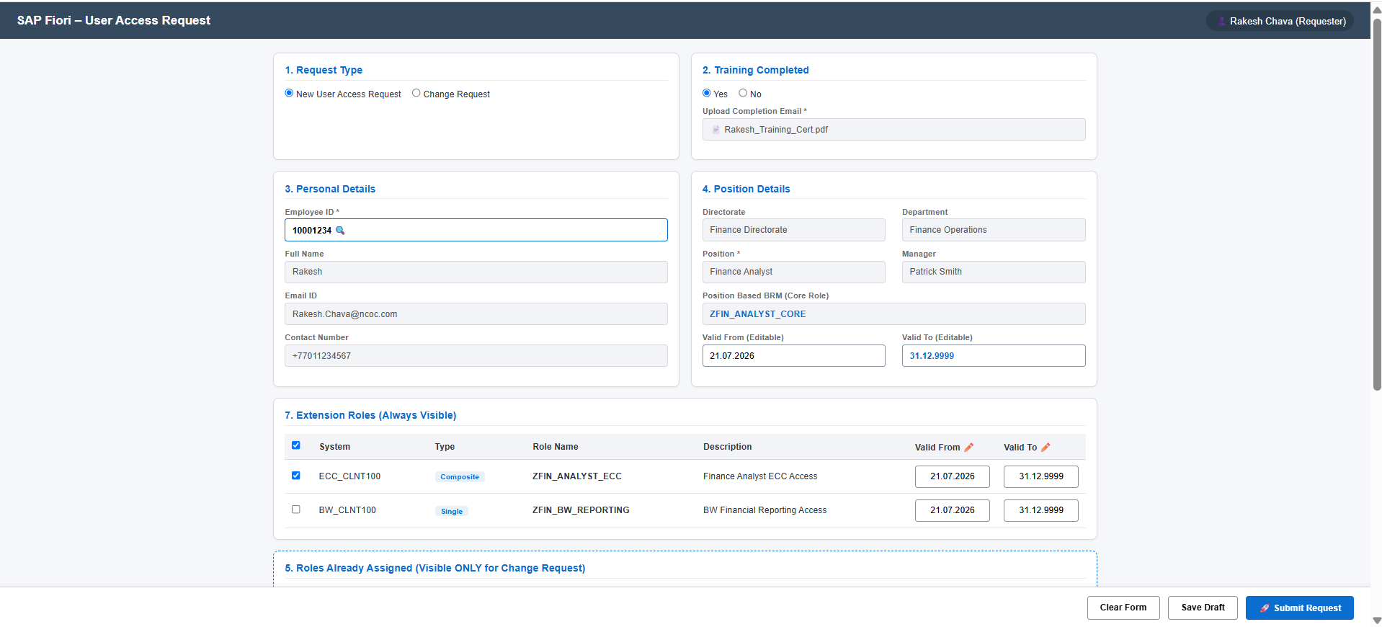
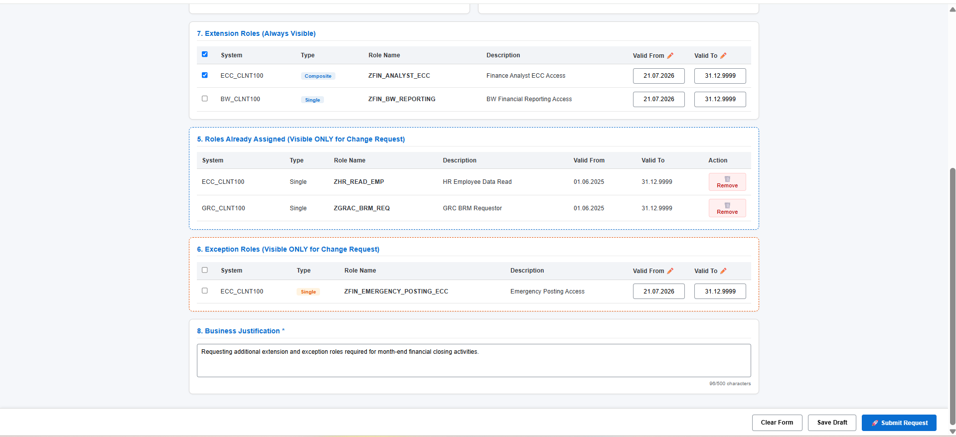

1.3 Detailed Section Specifications & Business Rules
Section 1: Request Type
- Control Type: Radio Button Group.
- Options: New User Access Request (Default) | Change Request.
- Functional Behaviour:
  - When New User Access Request is selected: Hide Section 5 and Section 6.
  - When Change Request is selected: Display Section 5 and Section 6. Trigger backend APIs to fetch user's assigned roles and exception roles.
Section 2: Training Completed
- Control Type: Radio Toggle (Yes / No) + File Attachment Uploader (.pdf, .jpg, .png, Max size: 5MB).
- Business Logic:
  - If Yes: File attachment is mandatory. Full role catalog (Extension & Exception) is made available.
  - If No: File attachment control is disabled. Restrict accessible roles strictly to fallback roles (e.g., PM013, PM013_CON).
Section 3: Personal Details
- Hydration Rule: Triggered immediately when the user inputs an Employee ID or selects an Employee ID from the Value Help (F4) dialog.
UI Label | Technical ID | Field Type | Data Source | UI State
Employee ID | txt_empId | Input / Value Help | AD Attribute (employeeId / sAMAccountName) | Editable (Primary Key)
Full Name | txt_fullName | Text Input | AD Attribute (displayName) | Read-Only (Auto-filled)
Email ID | txt_email | Text Input | AD Attribute (mail) | Read-Only (Auto-filled)
Contact Number | txt_contact | Text Input | AD Attribute (telephoneNumber) | Read-Only (Auto-filled)

Section 4: Position Details
- Hydration Rule: Auto-populated from Active Directory and custom table ZGRC_POS_ROLE_MAP upon resolving the Employee ID.
UI Label | Technical ID | Field Type | Source & Lookup Logic | UI State
Directorate | txt_directorate | Text Input | AD Attribute (department org structure) | Read-Only
Department | txt_department | Text Input | AD Attribute (department) | Read-Only
Position | txt_position | Text Input | AD Attribute (title) $→$ Mapped as POSITION_ID | Read-Only
Manager | txt_manager | Text Input | AD Attribute (manager DN lookup) | Read-Only
Position Based BRM | txt_posBrm | Text Input | Queried from ZGRC_POS_ROLE_MAP where POSITION_ID = Position AND ROLE_CATEGORY = 'CORE'. | Read-Only
Valid From | dt_validFrom | Date Picker | Defaults to Current Date (e.g., 21.07.2026). | Editable
Valid To | dt_validTo | Date Picker | Defaults to 31.12.9999. | Editable

Section 7: Extension Roles (Always Visible)
- Visibility Rule: Always rendered for both New User Access and Change Request.
- Data Source: Custom table ZGRC_POS_ROLE_MAP where POSITION_ID = [Derived Position] AND ROLE_CATEGORY = 'EXTENSION'.
Table Column | Control Type | Default Value / Logic | UI State
Select | Checkbox | Default: Unchecked (User selects required roles) | Editable
System | Text Label | Target System Connector (e.g., ECC_CLNT100, BW_CLNT100) | Read-Only
Role Type | Badge | Single (SIN) or Composite (CMP) | Read-Only
Role Name | Text Label (Bold) | Technical Role Name (e.g., ZFIN_BW_REPORTING) | Read-Only
Description | Text Label | Functional Role Description | Read-Only
Valid From | Date Picker | Defaults to Section 4 Valid From date | Editable
Valid To | Date Picker | Defaults to Section 4 Valid To date (31.12.9999) | Editable

Section 5: Roles Already Assigned (Change Request Only)
- Visibility Rule: Visible only when Request Type = Change Request.
- Data Source: SAP GRC Web Service GRAC_USER_GET_DETAIL_WS.
Table Column | Control Type | Logic & Action | UI State
System | Text Label | Connector ID where role is currently assigned | Read-Only
Role Type | Text Label | Single / Composite / Business Role | Read-Only
Role Name | Text Label (Bold) | Assigned Technical Role Name | Read-Only
Description | Text Label | Functional Description | Read-Only
Valid From | Text Label | Existing assignment start date | Read-Only
Valid To | Text Label | Existing assignment end date | Read-Only
Action | Icon Button | Delete Icon: Clicking marks line item with <ProvAction> = 009 (Remove) in final request payload. | Editable

Section 6: Exception Roles (Change Request Only)
- Visibility Rule: Visible only when Request Type = Change Request.
- Data Source: Custom table ZGRC_POS_ROLE_MAP where POSITION_ID = [Derived Position] AND ROLE_CATEGORY = 'EXCEPTION'.
Table Column | Control Type | Default Value / Logic | UI State
Select | Checkbox | Default: Unchecked | Editable
System | Text Label | Target System Connector | Read-Only
Role Type | Badge | Role Type (SIN / CMP) | Read-Only
Role Name | Text Label (Bold) | Technical Exception Role Name (e.g., ZFIN_EMERGENCY_POSTING_ECC) | Read-Only
Description | Text Label | Functional Description | Read-Only
Valid From | Date Picker | Defaults to Section 4 Valid From date | Editable
Valid To | Date Picker | Defaults to Section 4 Valid To date (31.12.9999) | Editable

Section 8: Business Justification
- Control Type: Multi-line Text Area.
- Validation Rules: Mandatory field. String length must be between 10 and 500 characters. Real-time character counter displayed.

1.4 Form Visibility & Data Rule Summary Matrix
Section ID & Title | Visible in New Request? | Visible in Change Request? | Primary Data Source | Auto-Hydration Trigger
Sec 1: Request Type | Yes | Yes | User Input | Page Load
Sec 2: Training Completed | Yes | Yes | User Input / File Store | User Toggle
Sec 3: Personal Details | Yes | Yes | Active Directory (AD / LDAP) | Employee ID Change
Sec 4: Position Details | Yes | Yes | AD + ZGRC_POS_ROLE_MAP | Employee ID Change
Sec 7: Extension Roles | Yes | Yes | ZGRC_POS_ROLE_MAP (EXTENSION) | Position Resolved
Sec 5: Assigned Roles | No | Yes | GRC WS (GRAC_USER_GET_DETAIL_WS) | Change Request Selected
Sec 6: Exception Roles | No | Yes | ZGRC_POS_ROLE_MAP (EXCEPTION) | Change Request Selected
Sec 8: Justification | Yes | Yes | User Input | User Typing

SECTION 2: TECHNICAL SPECIFICATION (TS)

2.1 End-to-End System Integration Flow
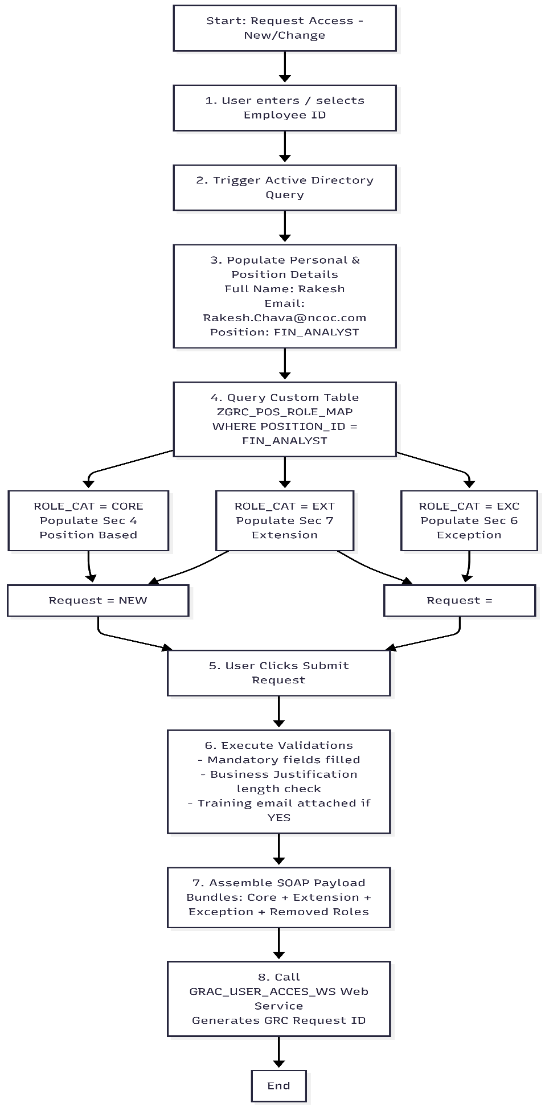

2.2 Custom Database Table Schema (ZGRC_POS_ROLE_MAP)
Create custom table ZGRC_POS_ROLE_MAP in the SAP GRC backend client via transaction SE11.
- Table Name: ZGRC_POS_ROLE_MAP
- Short Description: Position to Role Category Mapping Table

Field Name | Key | Data Element | Data Type | Length | Domain / Allowed Values | Technical Description
MANDT | X | MANDT | CLNT | 3 | — | Client ID
POSITION_ID | X | CHAR20 | CHAR | 20 | String | Position Code / Functional Area
ROLE_NAME | X | AGR_NAME | CHAR | 30 | String | Technical SAP Role Name
SYSTEM_CONNECTOR |  | CHAR30 | CHAR | 30 | Connector Name | Target System (e.g., ECC_CLNT100)
ROLE_CATEGORY |  | CHAR10 | CHAR | 10 | CORE, EXTENSION, EXCEPTION | Role Classification Category
ROLE_TYPE |  | CHAR10 | CHAR | 10 | SIN, CMP, BUS | Single, Composite, or Business Role
ROLE_DESC |  | CHAR100 | CHAR | 100 | String | Functional Role Description
TRAINING_REQ |  | CHAR1 | CHAR | 1 | X / | X = Attachment mandatory
IS_ACTIVE |  | CHAR1 | CHAR | 1 | X / | Status Flag (X = Active)

2.3 Interface & API Specifications
Interface 1: Active Directory Profile Lookup (LDAP / Graph API)
- Trigger: Input / Value Help change on Employee ID (txt_empId).
- Protocol: REST API / Microsoft Graph API (GET /v1.0/users/{employeeId}) or LDAP RFC.
- Response Field Mapping:
AD Response Attribute | Mapped Front-End Field | Field ID
displayName | Full Name | txt_fullName
mail | Email ID | txt_email
telephoneNumber | Contact Number | txt_contact
department | Department | txt_department
title | Position (POSITION_ID) | txt_position
manager | Manager Name | txt_manager

Interface 2: Custom Role Lookup OData Service (ZGRC_ROLE_LOOKUP_SRV)
- Service Name: ZGRC_ROLE_LOOKUP_SRV
- Entity Set: PosRoleSet
- HTTP Method: GET
- Query Filter Example: /sap/opu/odata/sap/ZGRC_ROLE_LOOKUP_SRV/PosRoleSet?$filter=POSITION_ID eq 'FIN_ANALYST' and IS_ACTIVE eq 'X'

Sample OData JSON Response Schema:
JSON
{
"d": {
"results": [
{
"PositionId": "FIN_ANALYST",
"RoleName": "ZFIN_ANALYST_CORE",
"Connector": "ECC_CLNT100",
"RoleCategory": "CORE",
"RoleType": "CMP",
"RoleDesc": "Baseline Core Access Role for Finance Analyst",
"TrainingReq": "N"
},
{
"PositionId": "FIN_ANALYST",
"RoleName": "ZFIN_BW_REPORTING",
"Connector": "BW_CLNT100",
"RoleCategory": "EXTENSION",
"RoleType": "SIN",
"RoleDesc": "BW Financial Reporting Access",
"TrainingReq": "N"
},
{
"PositionId": "FIN_ANALYST",
"RoleName": "ZFIN_EMERGENCY_POSTING_ECC",
"Connector": "ECC_CLNT100",
"RoleCategory": "EXCEPTION",
"RoleType": "SIN",
"RoleDesc": "Emergency Posting Access (Exception Role)",
"TrainingReq": "Y"
}
]
}
}

Interface 3: Query Assigned Roles (GRAC_USER_GET_DETAIL_WS)
- Service Name: GRAC_USER_GET_DETAIL_WS
- Trigger Event: Selected Request Type = Change Request.
- SOAP Action: Query current active role assignments for the Employee ID.
SOAP Input Parameters:
- <USER_ID> = 10001234
- <CONNECTOR> = ALL / System list
Output Mapping to Section 5 Table:
- <CONNECTOR> $→$ System Column
- <ROLE_TYPE> $→$ Role Type Column
- <ROLE_NAME> $→$ Role Name Column
- <ROLE_DESC> $→$ Description Column
- <VALID_FROM> $→$ Valid From Column (Read-Only)
- <VALID_TO> $→$ Valid To Column (Read-Only)

Interface 4: Create GRC Access Request (GRAC_USER_ACCES_WS)
- Service Name: GRAC_USER_ACCES_WS
- Binding URL: /sap/bc/srt/rfc/sap/grac_user_acces_ws/<client>/grac_user_acces_ws/binding
- Trigger Event: User clicks Submit Request.

Provisioning Action Rules (<ProvAction>):
- Assign Role (Add): 006 (Used for Core, Extension, and Exception roles).
- Remove Role (Delete): 009 (Used for roles selected for deletion in Section 5).

Complete XML Payload Schema:
XML
<soapenv:Envelope xmlns:soapenv="http://schemas.xmlsoap.org/soap/envelope/" xmlns:urn="urn:sap-com:document:sap:soap:functions:mc-style">
<soapenv:Header/>
<soapenv:Body>
<urn:GracIdmUsrAccsReqServices>

<!-- REQUEST HEADER DATA -->
<RequestHeaderData>
<ReqType>002</ReqType> <!-- 001 = New Access, 002 = Change Access -->
<Priority>003</Priority> <!-- 003 = Medium -->
<ReqInitSystem>CUSTOM_FIORI_PORTAL</ReqInitSystem>
<Requestorid>10001234</Requestorid>
<Email>Rakesh.Chava@ncoc.com</Email>
<RequestReason>Section 8 Text: Requesting extension and exception access required for month-end financial closing activities.</RequestReason>
<Funcarea>FIN_ANALYST</Funcarea>
</RequestHeaderData>

<!-- TARGET USER PERSONAL DETAILS -->
<UserInfo>
<item>
<Userid>10001234</Userid>
<Fname>Rakesh</Fname>
<Lname>Chava</Lname>
<Email>Rakesh.Chava@ncoc.com</Email>
<TelNo>+7 701 123 4567</TelNo>
<Department>Finance Operations</Department>
<Title>Finance Analyst</Title>
</item>
</UserInfo>

<!-- BUNDLED REQUESTED ROLES (CORE + EXTENSION + EXCEPTION + REMOVALS) -->
<RequestedLineItem>

<!-- 1. AUTOMATICALLY INCLUDED CORE ROLE (SECTION 4: POSITION BASED BRM) -->
<item>
<ItemName>ZFIN_ANALYST_CORE</ItemName>
<Connector>ECC_CLNT100</Connector>
<ProvItemType>ROL</ProvItemType>
<ProvAction>006</ProvAction> <!-- 006 = Assign -->
<RoleType>CMP</RoleType>
<ValidFrom>20260721</ValidFrom>
<ValidTo>99991231</ValidTo>
</item>

<!-- 2. SELECTED EXTENSION ROLE (SECTION 7) -->
<item>
<ItemName>ZFIN_BW_REPORTING</ItemName>
<Connector>BW_CLNT100</Connector>
<ProvItemType>ROL</ProvItemType>
<ProvAction>006</ProvAction>
<RoleType>SIN</RoleType>
<ValidFrom>20260721</ValidFrom>
<ValidTo>99991231</ValidTo>
</item>

<!-- 3. SELECTED EXCEPTION ROLE (SECTION 6 - CHANGE REQUEST MODE) -->
<item>
<ItemName>ZFIN_EMERGENCY_POSTING_ECC</ItemName>
<Connector>ECC_CLNT100</Connector>
<ProvItemType>ROL</ProvItemType>
<ProvAction>006</ProvAction>
<RoleType>SIN</RoleType>
<ValidFrom>20260721</ValidFrom>
<ValidTo>99991231</ValidTo>
</item>

<!-- 4. REMOVED ROLE (SECTION 5 - CHANGE REQUEST MODE) -->
<item>
<ItemName>ZOLD_FIN_VIEWER_ECC</ItemName>
<Connector>ECC_CLNT100</Connector>
<ProvItemType>ROL</ProvItemType>
<ProvAction>009</ProvAction> <!-- 009 = Remove -->
<RoleType>SIN</RoleType>
<ValidFrom>20250601</ValidFrom>
<ValidTo>99991231</ValidTo>
</item>

</RequestedLineItem>

</urn:GracIdmUsrAccsReqServices>
</soapenv:Body>
</soapenv:Envelope>

SECTION 3: GRC CONFIGURATION & PREREQUISITES
The SAP GRC Consultant must execute the following backend configuration steps prior to application launch:

3.1 Web Service Activation (SICF Transaction)
Ensure the following ICF nodes are active in transaction SICF:
- /sap/bc/srt/rfc/sap/grac_user_acces_ws
- /sap/bc/srt/rfc/sap/grac_user_get_detail_ws
- /sap/opu/odata/sap/ZGRC_ROLE_LOOKUP_SRV

3.2 MSMP Workflow Binding (SPRO)
- Process ID: SAP_GRAC_ACCESS_REQUEST
- Initiator Rule: Bind initiator to evaluate incoming <Funcarea> (FIN_ANALYST) and route to the respective Business Role Manager (BRM) path.
- Notification Variables: Ensure LINK_APPROVE_REJECT is enabled in MSMP stage configuration for manager approval emails.

